**Build Instructions**

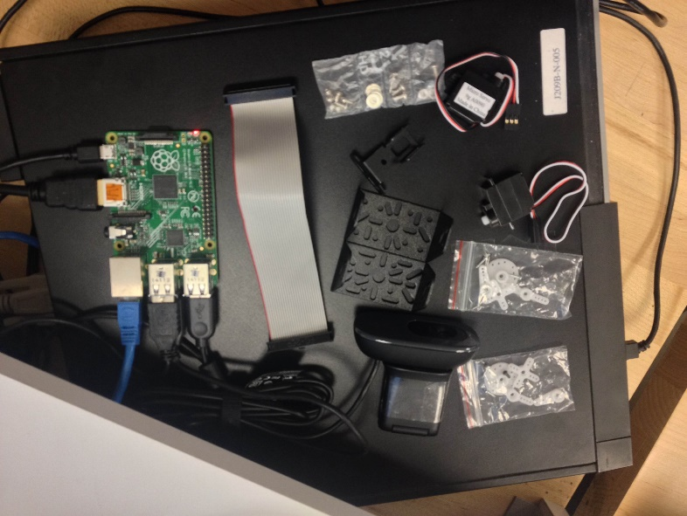

Step 1: Gather all components.

Raspberry pi

Pan/tilt bracket

2 servo motors

USB camera

Servo/PWM pi hat

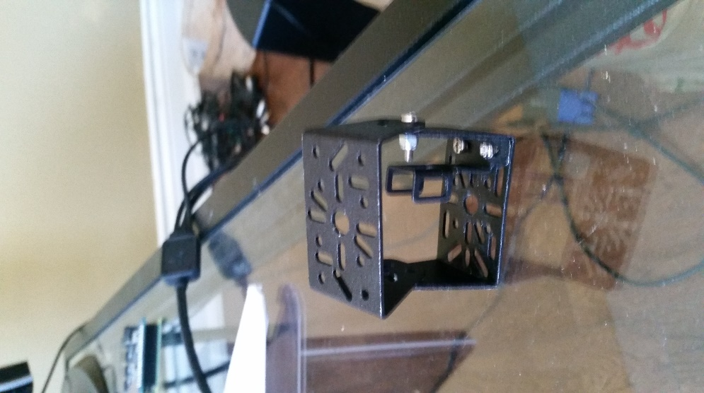

Step 2: Connect Pan/Tilt bracket

Step 3: attach the servo motors (bottom first).

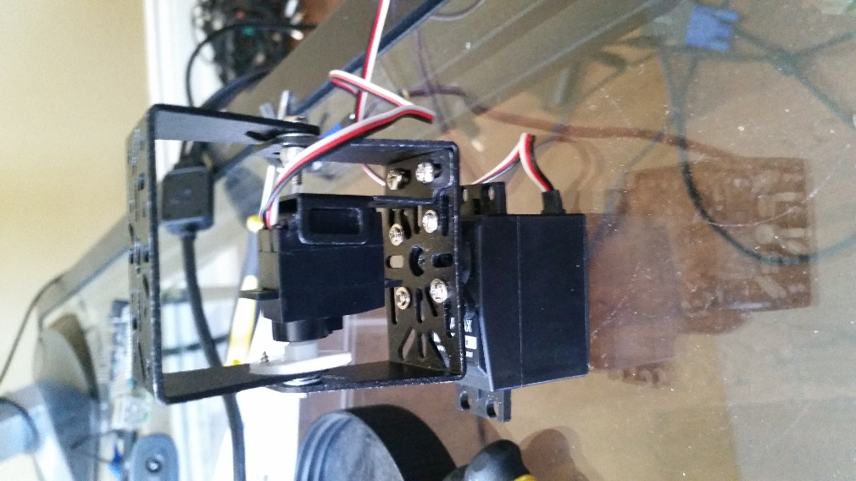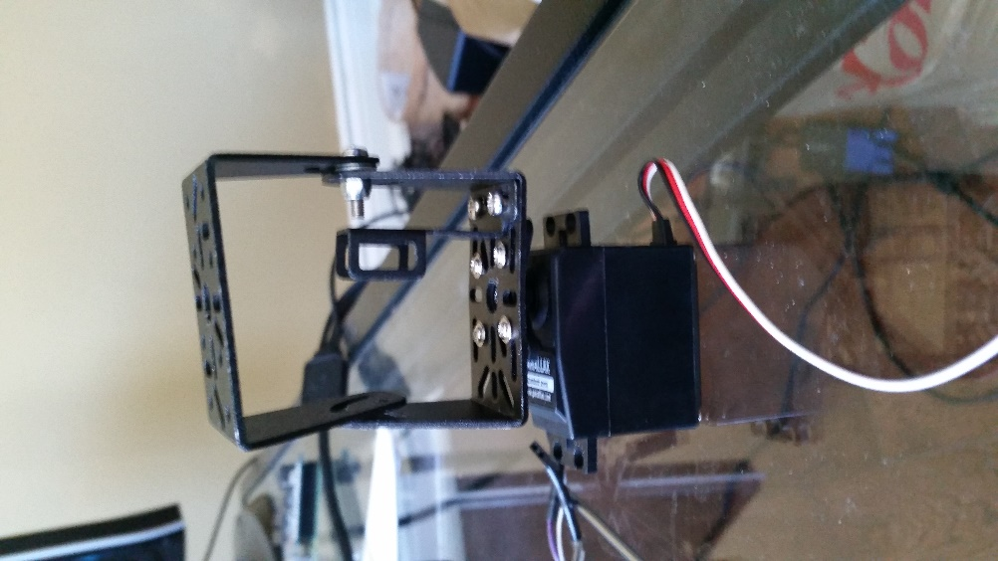

Step 4: connect the pi hat to the GPIO pins of the raspberry and then connect the servo motors to the hat.

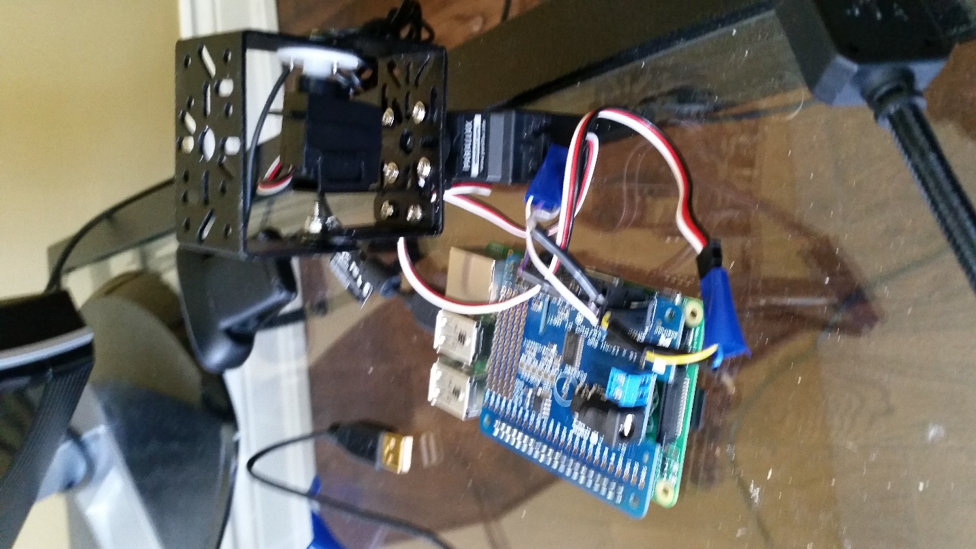

Step 5: attach the camera to the bracket. You can secure with tape if needed. The Case is optional and can be created to your liking.

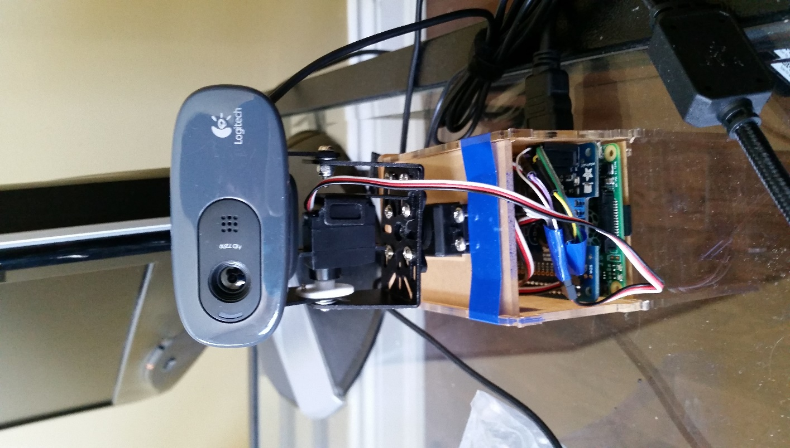

Step 6: Downloading all necessary software for the scripts.

You will need to download:

Python-OpenCV library from raspbian

VLC media player to connect to the stream

Gstreamer 1.0 library

Adafruit pi hat libraries from tutorial (<https://learn.adafruit.com/adafruit-16-channel-pwm-servo-hat-for-raspberry-pi/powering-servos>) this also shows how to connect the hat to the pi.